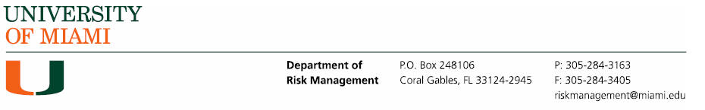

International Travel Risk Assessment
You may answer questions within this document, or ensure that the answers to these questions are included in your proposal.

- Please submit a detailed itinerary, which at a minimum lists all locations you will be visiting and duration of stay in each location. A final, fully updated itinerary must be submitted at least 4 weeks prior to departure.
- Do you have the means to communicate (cellular/satellite phone etc.) while abroad?
- How will you communicate safe arrival/departure and itinerary changes?
- Do you speak the local language at the destination? If not, is English spoken widely? If not, will you have access to a translator?
- Are there Level 3 or 4 travel advisories published by the US Department of State for the locations you will travel to? If yes, you will need to complete the International Travel Authorization Form.
- Review the guidance from International SOS for the areas you will travel to and provide details on how you will mitigate/avoid the risks.
  - What are the medical and security risk ratings for the areas you will travel to based on ISOS guidance?
  - Are there any cultural/legal sensitivities that might put your group at a higher risk based on your group’s profile? (LGBTQ/religion/nationality/gender)
  - What is the standard of medical care in the areas you will be in? Based on your group’s medical profile will you be able to access medical care if needed?
  - Will you be able to follow all advice provided by ISOS?
- Have you received all vaccinations required by law at the country of destination?
  - Will you have been fully vaccinated (including boosters) for COVID-19 prior to your trip? (Note that some countries require the last immunization to be within a certain timeframe or a certain type of vaccine.)
- What other concerns do you have regarding this group’s travel and planned activities?
Should your program meet its minimum enrollment and be approved to operate, an internal Program Contact Sheet will be sent to you for completion. You will need to provide:
  - your co-faculty and/or TAs/PAs names and contact information,
  - program provider or other designated point(s) of contact at your destination(s),
  - your emergency point of contact at home (Miami/Coral Gables).

